5 Year
Long Cotuit Library
Range Association
Plan
This is the Cotuit Library  Association’s Five Year Long  Range Plan submitted in  accordance with the  Massachusetts  Board of Library  Commissioners  requirements. | Fiscal Years  2015 -  2020
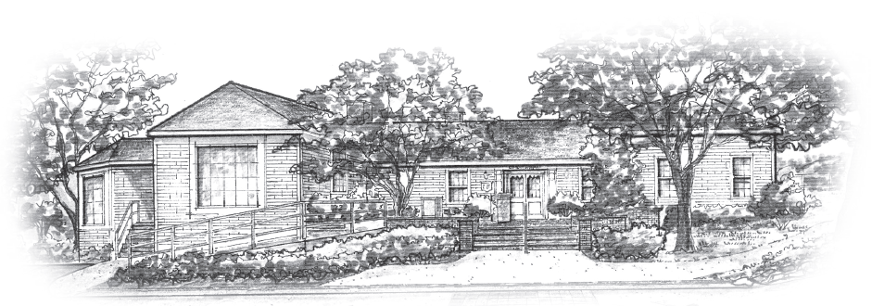

Table of Contents
Mission Statement 4
Introduction 5
Methodology 5
Community Description 5
Cotuit Demographics 5
Library Description 5
Mission and Vision 6
Needs Assessment 6
Service 7
Goal 1: Programming 7
Objective 1: Programs 7
Action 1: Marketing 7
Action 2: Diversity 7
Objective 2: Maker Spaces 7
Action1: Telescopes 7
Action 2: Baby Grand Piano 7
Action 3: Laptop Lab 7
Action 4: Circulating learning toy collection 7
Goal 2: Safety and Comfort 8
Objective 1: Maintentance 8
Action 1: Disaster Plan 8
Action 2: Facilities Plan 8
Objective 2: Staff Office Upgrade 8
Goal 3: Collaboration 8
Objective 1: Local Organizations Collaboration 8
Action 1:Senior Center 8
Action 2: Trainings ………………………………………………………………………….8
Action 3:Family Literacy 8
Objective 2: Library Collaboration. 9
Action 1Summer Reading Programs 9
Access 11
Goal 1: Provide patrons access to information resources of current interest. 11
Objective 1: Collection Review 11
Action 1: Weeding 11
Action 2: CLAMS Reports 11
Action 3: Withdrawal Schedule 11
Objective 2: Collection Additions. 11
Action 1: Print 11
Action 2: Databases 11
Action 3: E-Reference Library 11
Goal 2: Provide better access to library resources 11
Objective 1: Lift 11
Technology 12
Goal 1: 12
Objective 1: LapTop Lab 12
Objective 2: Technology Plan 12
Outreach 13
Goal 1: Reach 13
Objective 1: Social Media engagement 13
Objective 2: Newsletters 13
Objective 3: Staff Training 13
Plan Approval 14

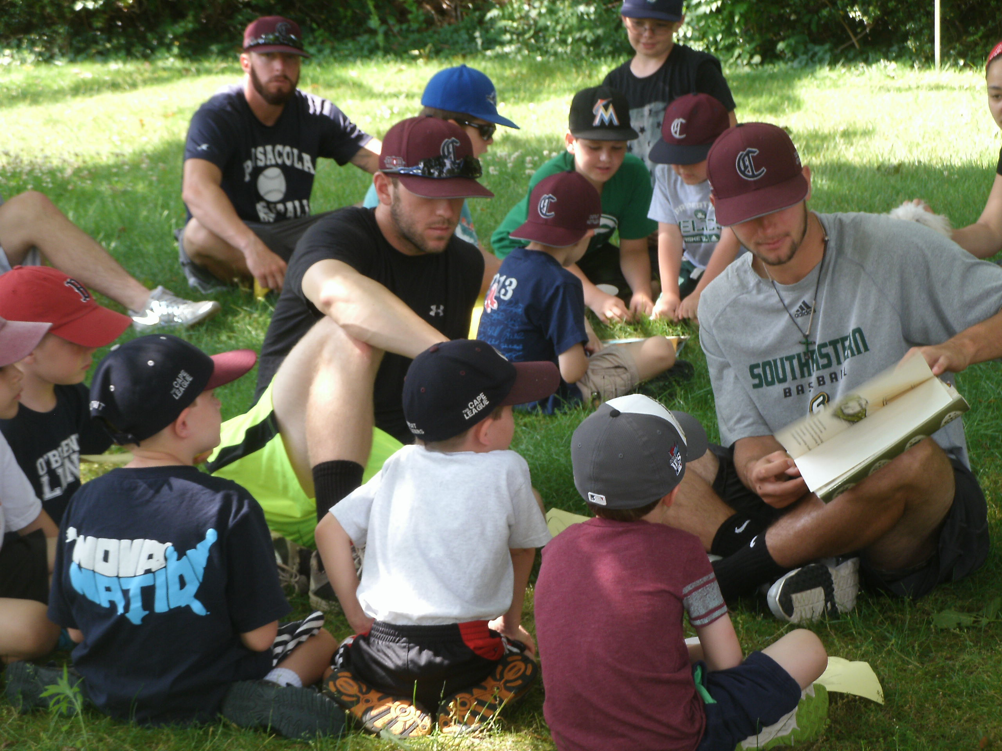
Summer-long collaborative program with the baseball camp run by the Cotuit Kettleers Association

Mission Statement
The Cotuit Library Association provides and promotes open and equal access to the library’s resources and services in order to support life-long learning, advance general and technical knowledge, encourage creativity, strengthen our town and the broader Cape Cod community, assist with the adaptation to new technology, and enhance individual quality of life.

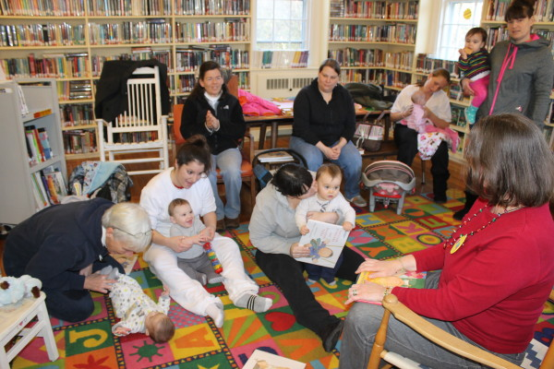
Family Literacy Program with the Angel House Transitional Housing
program for mothers and children

Introduction
Located on the edge of Nantucket Sound on Cape Cod, the Cotuit Library is at the heart of daily village life and one of seven valuable non-profit and independent libraries in the Town of Barnstable. Since its incorporation in 1891, this school room turned library has offered local residents and visitors a community center dedicated to meeting their needs for information, entertainment, and connection.

Methodology
With a special focus on local community input, two surveys conducted 16 months apart and an open community forum were held to collect the ideas and thoughts of our patrons. Both surveys were available in paper and digital formats and were kept open for a total of 60 days each. A total of 139 surveys were collected. The open forum attracted 45 key members of the community. These efforts spanned a 2 year period between July 2012 and March 2014, a total of 21 months.

The director solicited staff input during a day-long staff in-service and updated the trustees at their regularly scheduled meetings.

Community Description

The target audience for Cotuit Public Library is comprised of small businesses, year-round residents, and summer residents/tourists. Our village population is comprised by a large number of seniors and summer residents.

Cotuit Demographics
These numbers are taken from the 2010 Demographic Profile Data provided by the U.S. Census Bureau.
Total Population | 3,153
Male Population | 1,567
Female Population | 1,585
There are also 2,097 housing units, of which 1,201 are occupied year-round and 896 are seasonal or recreational residences. There are 401 households with children. More than 60% of the population is over the age of 50.
The current average household income is $91,000. The cost of living is 42% higher than in the rest of the United States. Unemployment was at 9% in the beginning of 2012; this number reflects the seasonal nature of work on Cape Cod. Over 95% of the residents are Caucasian.

Library Description
The Cotuit Library was founded by the Cotuit Lyceum Society. Its first permanent home was in the present entrance room, a former school house built in 1820 and acquired for the library in 1894. Through the years the following expansions have allowed the collection to grow: the Guy Lowell addition in 1901, the Richard Gallagher addition in 1963, and the Kirkman Extension (Phillip Minervino, Architect) in 1977. The library is owned and managed by the Cotuit Library Association with contributions from its members, special fundraising, and the Town of Barnstable.

The library is one of 35 members of the CLAMS (Cape Libraries Automated Materials Sharing) network. The shared system gives library card holders access to over 1.5 million items including books, magazines, and non-print resources. The libraries use a common ILS and OPAC and share delivery service through the Massachusetts Library System. The Cotuit Library is one of seven libraries in the town of Barnstable. The town has seven villages, each with its own library. These seven village libraries consist of all private libraries and participate in a cooperative Barnstable library “system” which collaborates on providing the best possible services to the residents. This attitude of collaboration replaces the competitive landscape which previously existed, and helps all seven libraries increase their community support and financial resources.

Mission and Vision
The library mission is, “The Cotuit Library Association provides and promotes open and equal access to the library’s resources and services in order to support life-long learning, advance general and technical knowledge, encourage creativity, strengthen our town and the broader Cape Cod community, assist with the adaptation to new technology, and enhance individual quality of life.” This mission statement was created in 2012. With this mission in mind, the library envisions its role as central to the community’s stability and quality of life, reaching out and connecting with our current and potential patrons. While the library is physically small, it intends its impact to be one of significance.

Needs Assessment

The library conducted two surveys and a community meeting over a 24 month period to asses the current needs. This process defined four key areas of focus: Service, Access, Technology and Outreach. These provided a framework for the following plan as we addressed the particular needs discussed by the community.

Service

Goal 1: Programming

Objective 1: The library will provide a variety of well-publicized and diverse library sponsored programs and events for all ages.

Action 1: Marketing

Library programs will be publicized in a biannual print newsletter, on the website, the library social media and e-newsletter, on various local events calendars, and through press releases to local media

Action 2: Diversity

Children’s programs will promote basic literacy, family literacy, STEAM topics, and creativity. Adult programs will include topics on art, music, crafts, history, science, literature, technology, literacy and language.

Objective 2: The library will work to provide several maker spaces for patrons to use for hands-on learning and creating

Action1: Telescopes

The library will add three telescopes to the collection for use by patrons, schools, and astronomy groups. In addition the library will hold several astronomy programs through the year to encourage use and knowledge about the telescopes and the topic.

Action 2: Baby Grand Piano

The library will add a piano to the collection for use by patrons for composition, performance, and practice.

Action 3: Laptop Lab

The library will create a lab of 12 laptops with software for music composition, film-making, digital publishing, etc. These laptops will be digital maker spaces. The library will hold trainings on the different software to aid in the creative process of our patrons

Action 4: Circulating learning toy collection

The library will create a circulating toy library to encourage parents to begin their children’s adventure in learning by doing without the high personal cost of purchasing the toys themselves. All toys purchased will focus on skill building by developmental milestone, creative play, and encouragement of a maker mindset.

Goal 2: Safety and Comfort

Objective 1: The library will ensure plans for keeping the buildings, grounds, and collection in their best possible condition are created

Action 1: Disaster Plan
The library will complete and update annually a disaster plan.

Action 2: Facilities Plan
The library will complete and update bi-annually a facilities plan to be used for maintaining the current plant and assessing the upcoming need for the facility.

Objective 2: Staff Office Upgrade

Action 1: A new office will be built to accommodate staff needs for a work space that is accessible to the front desk but private and quiet for accomplishing their tasks.

Action 2: A kitchen and break room will be relocated and remodeled for staff use.

Goal 3: Collaboration

Objective 1: The library will collaborate with local organizations.

Action 1: The library will collaborate with the Senior Center to provide digital literacy trainings

Action 2: The library will provide trainings to local nonprofits on digital literacy.

Action 3: The library will collaborate with local shelters to provide digital literacy trainings and family literacy trainings

Objective 2: The library will co-sponsor one collaborative event each season with other libraries.

Action 1: The library will collaborate with the Barnstable Libraries on Summer Reading Programs

Access

Goal 1: Provide patrons access to information resources of current interest.

Objective 1: The collection will be reviewed for currency, accuracy and relevance

Action 1: Review and update schedule for weeding

Action 2: Generate CLAMS reports on circulation & currency of collection

Action 3: Implement withdrawal schedule

Objective 2: The library will add a variety of print and digital materials to the collection.

Action 1: Add 1,200 print titles each year to the collection

Action 2: Maintain at least 4 databases for research and skill building

Action 3: Maintain and increase the number of titles in our e-reference library accessible from mobile devices

Action 4: Purchase digital titles from Overdrive, Advantage, and participate in the Statewide E-book project.

Goal 2: Provide better access to library resources

Objective 1: Lift

Action 1: Install a lift that will give patrons access to all three floors of the library

Action 2: Build an accessible restroom on the top floor

Action 3: Change the shelving layout in the basement to create wider aisles for browsing

Technology

Goal 1: Provide access to laptops for creation and training purposes

Objective 1: LapTop Lab
Action 1: Build a lab with 12 laptops for patron use inside the library and for embedded projects with our collaborating partners

Action 2: Install software that helps patrons create content, giving them a digital maker space
Action 3: Install software that helps the library give effective digital literacy trainings both inside and outside the building

Objective 2: Technology Plan

Action 1: Create a technology plan to aid the library in maintenance, procurement, and replacement needs

Outreach

Goal 1: Increase the library’s reach in the community

Objective 1: Social Media engagement
Action 1: Work to increase online engagement with patrons in Facebook and Twitter

Action 2: Start a blog

Action 3: Begin an online book club

Objective 2: Newsletters

Action 1: Create a print newsletter that is mailed to every residence in the village 2 times per year

Action 2: Create an email newsletter that is pushed to subscribers once per week

Objective 3: Staff Training

Action 1: Increase staff training in the following areas to aid in our collaborative work: The needs of seniors and older adults, the conditions and barriers to information by the homeless and transitional housing populations, the gaps digital literacy learning and the best practices for closing those gaps in our community

